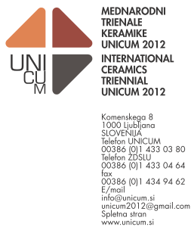

ENTRY FORM

INFORMATION ABOUT THE AUTHOR

Name........................................ Surname................................................. Date of birth …….
Address:
Street and house number …...................................................................................................
Code..................... Town …………………………….………Country …..……………………….
Phone / cell No (with state and area number).......................…………………........................
e-mail ………………………………………………....................................................................

Education (course and degree)

……………………………………………..…………………

Important personal and group exhibitions

……………………………………………………………
……………………………………………………………
……………………………………………………………
……………………………………………………………
……………………………………………………………
……………………………………………………………
……………………………………………………………
……………………………………………………………
……………………………………………………………
…………………………………………………………………………………………………………

Awards

……………………………………………………………
……………………………………………………………
……………………………………………………………
……………………………………………………………
…………………………………………………………………………
………………………………
INFORMATIONS ABOUT ARTWORKS

Title(1)................................................................................................... year..........................
Material...................................................................................................................................
Technique...............................................................................................................................
Dimensions (cm):
Height ........................ width …..................... depth................................................................
Insurance sum in eur ………………........................................................................................
Numbering of the attached photos……………….…..,………………………,…………..…...….
Other information: ……………….............................................................................................

Title (2)................................................................................................... year.........................
Material...................................................................................................................................
Technique …...........................................................................................................................
Dimensions (cm):
Height ........................ width …..................... depth................................................................
Insurance sum in eur…………………………….….……………...............................................
Numbering of the attached photos……………….…..,………………………,…………..…...….
Other information: …………………………………...…………..................................................

Title (3).................................................................................................... year.......................
Material...................................................................................................................................
Technique…………….............................................................................................................
Dimensions (cm):
Height ........................ width …..................... depth………………………...............................
Insurance sum in eur………………..……………………………...............................................
Numbering of the attached photos……………….…..,………………………,…………..…...….
Other information: ……………………………………...………..................................................

With this application the artist agrees with entry conditions and assures that each ceramic artwork is his/her work that was created within last three years.

Date: Name and surname of the author:

Signature:

Entry send to: unicum2012@gmail.com
or: ZDSLU, II International Triennial of Ceramics Unicum 2012, Komenskega 8
1000 Ljubljana, Slovenia

For additional information go to our web page www.unicum.si or write on: info@unicum.si

