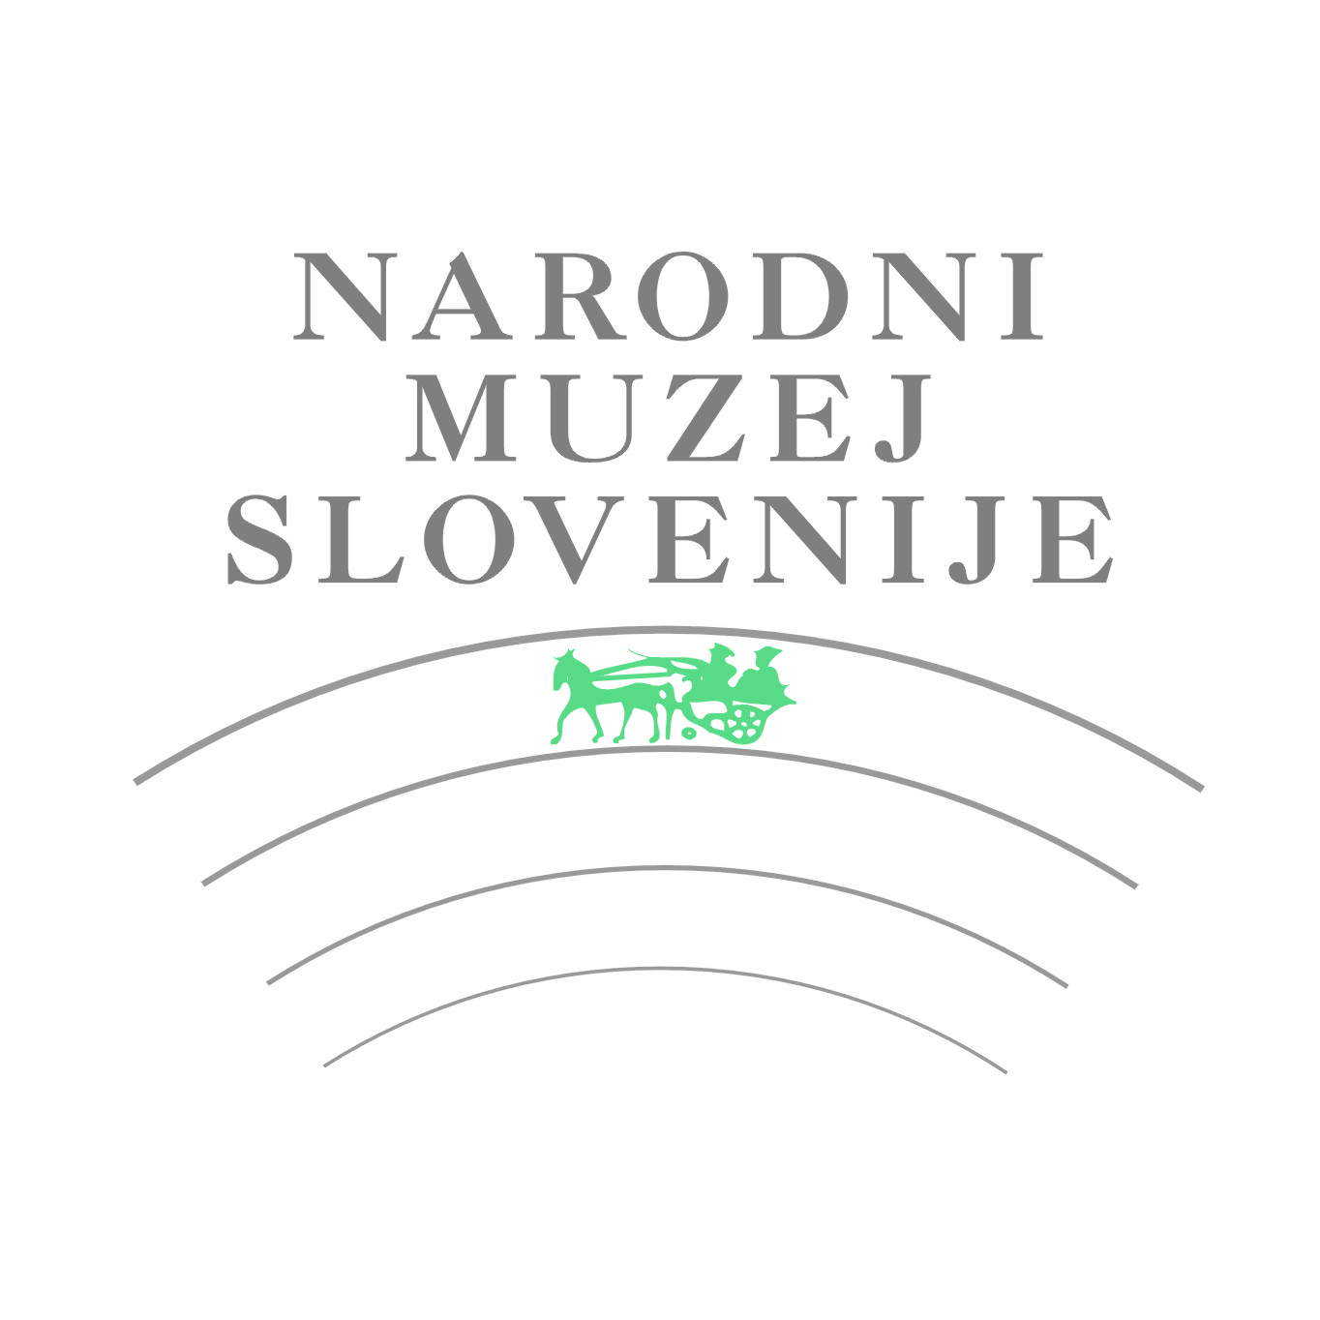
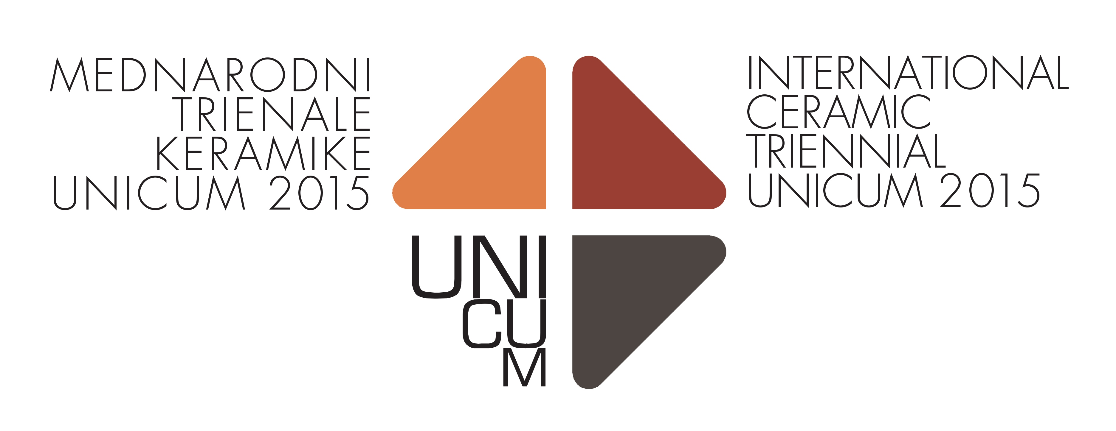

APPLICATION FORM

INFORMATION ABOUT AUTHOR

First name.................................. Surname....................................Nationality………........................
Date of birth ………………………….Place of birth...……………………………………………….…..
Address…..........................................................................................................................................
Postcode..................... City …………………………….………Country …..……………………….….
Phone / Mobile (with state and area number).......................…………………..................................
e-mail ………………………………………………...............................................................................

Education (course and degree)

……………………………………………..…………………

Important individual and group exhibitions

……………………………………………………………
……………………………………………………………
……………………………………………………………
……………………………………………………………
……………………………………………………………
……………………………………………………………
……………………………………………………………
……………………………………………………………
……………………………………………………………
…………………………………………………………………………………………………………

Awards

……………………………………………………………
……………………………………………………………
……………………………………………………………
……………………………………………………………
…………………………………………………………………………
………………………………
INFORMATION ABOUT ARTWORKS

Title (1)................................................................................................... Year..........................
Material....................................................................................................................................
Technique................................................................................................................................
Dimensions (cm):
Height ........................ Width …..................... Depth................................................................
Insurance sum in EUR ………………........................................................................................
Other information: ……………….............................................................................................

Title (2)................................................................................................... Year.........................
Material....................................................................................................................................
Technique …............................................................................................................................
Dimensions (cm):
Height ........................ Width …..................... Depth.................................................................
Insurance sum in EUR…………………………….….……………................................................
Other information: …………………………………...…………...................................................

With this application, the artist agrees with entry conditions and assures that each ceramic artwork is his/her work, created within the last three years.

Date: Name and surname of the author:

Signature:

Please note the closing date for applications is 30 November 2014!

Send application form to: info@unicum.si

For additional information, visit our web page: www.unicum.si

