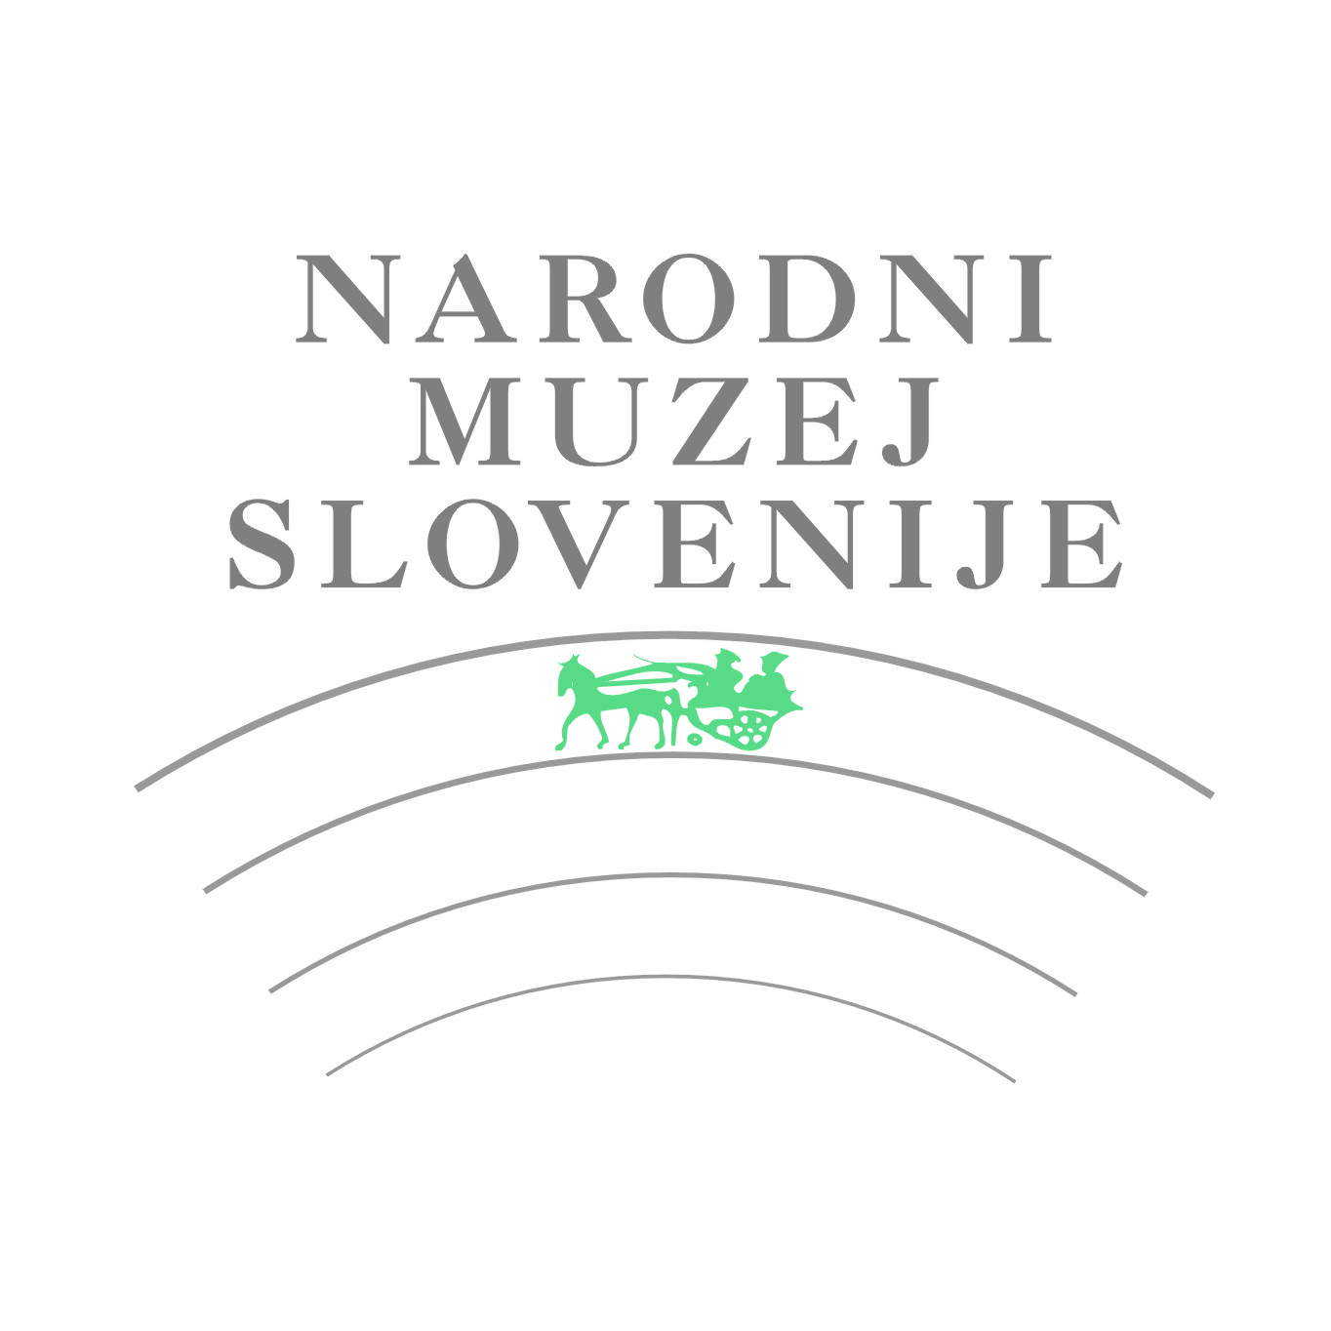
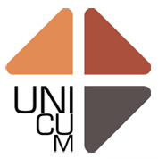

APPLICATION FORM

INFORMATION ABOUT AUTHOR

First name.................................. Surname....................................Nationality………........................
Date of birth ………………………….Place of birth...……………………………………………….…..
Address…..........................................................................................................................................
Postcode..................... City …………………………….………Country …..……………………….….
Phone / Mobile (with state and area number).......................…………………..................................
e-mail ………………………………………………...............................................................................

Education (course and degree)

……………………………………………..…………………

I confirm that my name, surname, nationality, country of residence, year of birth, e-mail, and education are published in the the catalogue of the Triennial (underline)……YES/NO…………………….…

Important individual and group exhibitions

……………………………………………………………
……………………………………………………………
……………………………………………………………
……………………………………………………………
……………………………………………………………
……………………………………………………………
……………………………………………………………
……………………………………………………………
……………………………………………………………
…………………………………………………………………………………………………………

Awards

……………………………………………………………
……………………………………………………………
……………………………………………………………
……………………………………………………………
…………………………………………………………………………
………………………………
INFORMATION ABOUT ARTWORKS

Title (1)................................................................................................... Year..........................
Material....................................................................................................................................
Technique................................................................................................................................
Dimensions (cm):
Height ........................ Width …..................... Depth................................................................
Author of the photo………………………………………………………………………………
Other information ……………….............................................................................................
Artist Statement (maximum 100 words) ………………....................................................................

Title (2)................................................................................................... Year.........................
Material....................................................................................................................................
Technique …............................................................................................................................
Dimensions (cm):
Height ........................ Width …..................... Depth.................................................................
Author of the photo………………………………………………………………………………
Other information: …………………………………...…………...................................................
Artist Statement (maximum 100 words) ………………....................................................................

With this application, the artist agrees with entry conditions and assures that each ceramic artwork is his/her work, created within the last five years.

Date: Name and surname of the author:

Signature:

Please note the closing date for applications is on Thursday, 1st December 2022!

Application form for the competitive part of the Triennial with all documentation required must be sent by email: info@unicum.si
Each author has to deliver:
- Correctly filled application form.
- Two photographs of each ceramic artwork from different angles in required format and printing quality, labeled with the title and dimensions of artwork in centimeters (e. g. Title of the Artwork_Dimensions_Picture1).
- Self-portrait photograph.

For additional information, visit our web page: www.unicum.si

