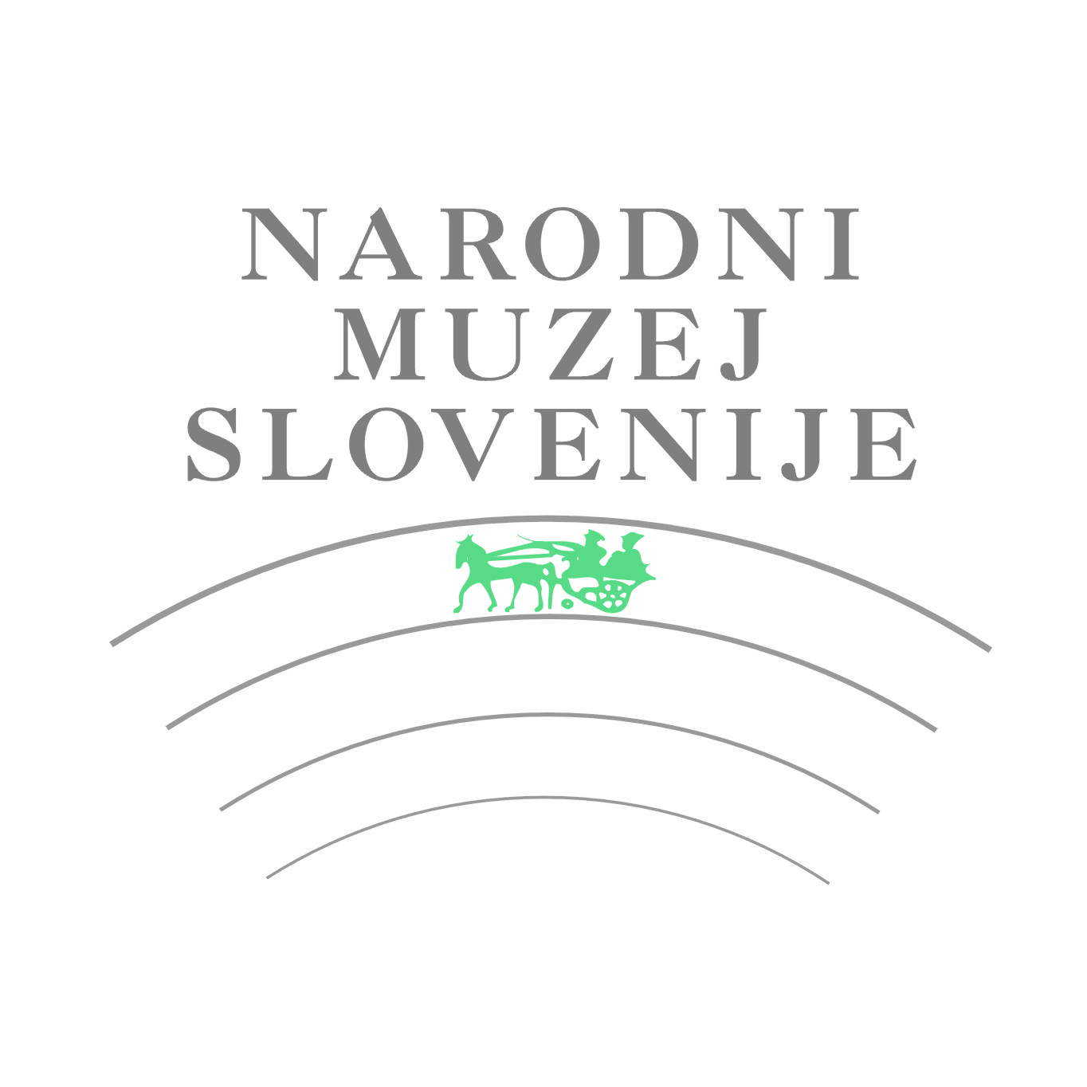


APPLICATION FORM

INFORMATION ABOUT AUTHOR

First name.................................. Surname....................................Nationality………........................
Date of birth ………………………….Place of birth...……………………………………………….…..
Address…..........................................................................................................................................
Postcode..................... City …………………………….………Country …..……………………….….
Phone / Mobile (with state and area number).......................…………………..................................
e-mail ………………………………………………...............................................................................

Education (course and degree)

……………………………………………..…………………

Important individual and group exhibitions

……………………………………………………………
……………………………………………………………
……………………………………………………………
……………………………………………………………
……………………………………………………………
……………………………………………………………
……………………………………………………………
……………………………………………………………
……………………………………………………………
…………………………………………………………………………………………………………

Awards

……………………………………………………………
……………………………………………………………
……………………………………………………………
……………………………………………………………
…………………………………………………………………………
………………………………
INFORMATION ABOUT ARTWORKS

Title (1)................................................................................................... Year..........................
Material....................................................................................................................................
Technique................................................................................................................................
Dimensions (cm):
Height ........................ Width …..................... Depth................................................................
Other information: ……………….............................................................................................

Title (2)................................................................................................... Year.........................
Material....................................................................................................................................
Technique …............................................................................................................................
Dimensions (cm):
Height ........................ Width …..................... Depth.................................................................
Other information: …………………………………...…………...................................................

With this application, the artist agrees with entry conditions and assures that each ceramic artwork is his/her work, created within the last three years.

Date: Name and surname of the author:

Signature:

Please note the closing date for applications is on Friday, 1st December 2017!

Send application form to: info@unicum.si

For additional information, visit our web page: www.unicum.si

